

**Name: Saleh Ahmed Alheeh**

**ID: 201614721**

**Name of project: Online flight booking Database**

**Outline**

1. **Introduction**
2. **Online Flight Booking**
3. **Online Flight booking Features**
4. **Electronic ticket**
5. **Requirements Online flight booking Database**
6. **ER Model diagram**
7. **Relational Schema**
8. **Implementation**
9. **Conclusion**

**Introduction**

Online Flight Booking : is a system that allows consumers and travel agents to book flights online. In today’s airline industry users or customers can reserve seat or book flight from any place in the world as long as they are connected to internet. The Innovation of technology has made traveling in the air easier for customers with airline reservation or booking just a click away. It's fast, convenient and easy to book, search, and compare without going to airlines' offices. When the ticket is booked, an electronic ticket will be sent via e-mail, and all the tickets are issued as an electronic ticket.

Online Flight booking Features:

1-Facilitate flight search

2-Compare the prices of services

3-High airline sales and income

4-Increase the number of customers for airlines

5-Facilitates administrative processes and reduces the number of employees because they combine more than one system in one system

Electronic ticket

An electronic ticket, often called e-ticket, is a digital ticket equivalent of a paper ticket. E-tickets were first issued about 1994.An electronic ticket is a ticketing option that eliminates the need for a physical ticket. Instead, your booking details are stored securely in our computers. When it’s time to travel, simply present your e-ticket, national id, or passport when checking in at the airport. If you book online in most countries, there’s no need to visit a local office to receive your ticket, simply print your e-ticket during the online booking process. When booking, every person traveling will get their own individual electronic ticket, including children and infants. Also, your booking information is stored in the database, there’s no ticket to misplace or lose, and your travel details can easily be changed at any time, without having to produce a paper ticket or visiting an airline office.

**Requirements Online flight booking Database:**

The system depends on the USER. The user has a name (FName , MName,LName), phone number, password, and Email. Email is unique for each user.The user has PAYMENT , adds the passengers to the trip, may has DISCOUNT, and booking TICKET. DISCOUNT has User id , CN/LN and Scale .The PAYMENT has a card name, card number, expritydate (Year, Month) , cvv and pays for the tickets and luggage . Card number has unique values for each card. TICKET has a Ticketid ,price, date(year, month, day, time), departure, destination, travel_class (First, business, Economy) .TICKET may has LUGGAGE and has Airline company. Ticketid has unique values for each ticket .The LUGGAGE has ID, luggage type, luggage weight. ID has unique values for each bag. The Airline company has Name , ID , country. ID has unique values for each airlines company. The passengers has a name (FirstName, MiddleName, LastName), birthdate(Year, Month,Day), PtID/NID,Ped (Passport expiry date) (Year, Month,Day),also has ticket . PtID/NID has unique values for each airlines passenger.

**ER Model diagram:**

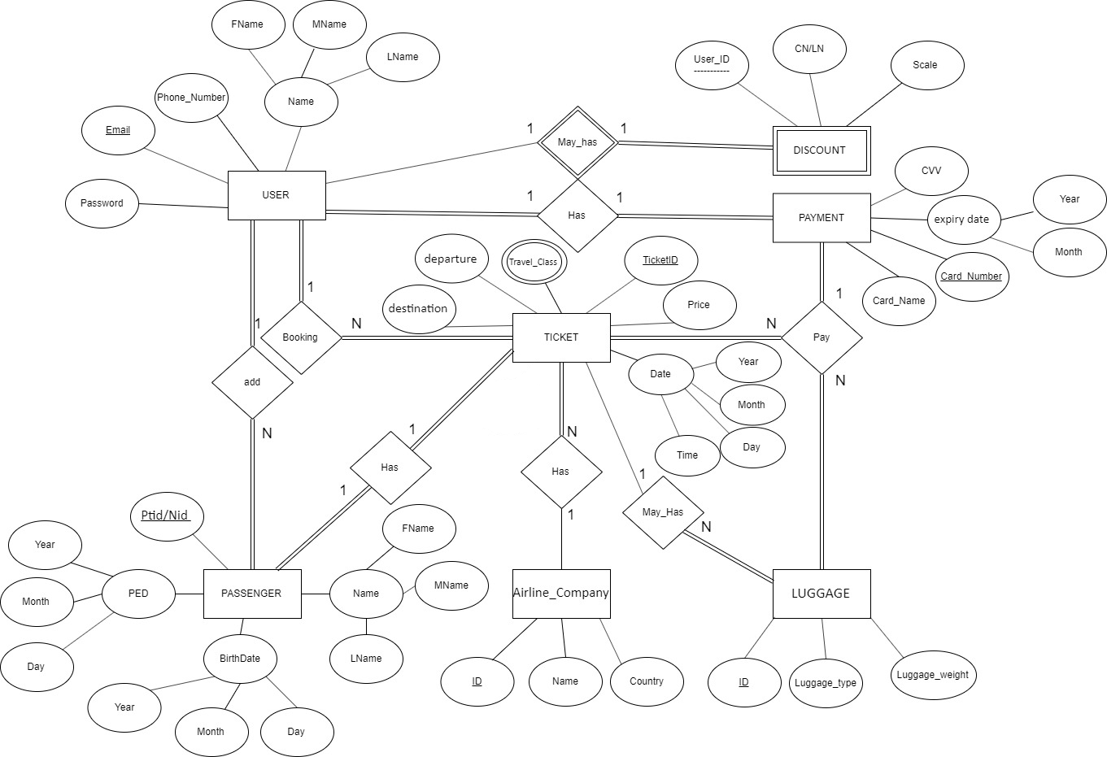

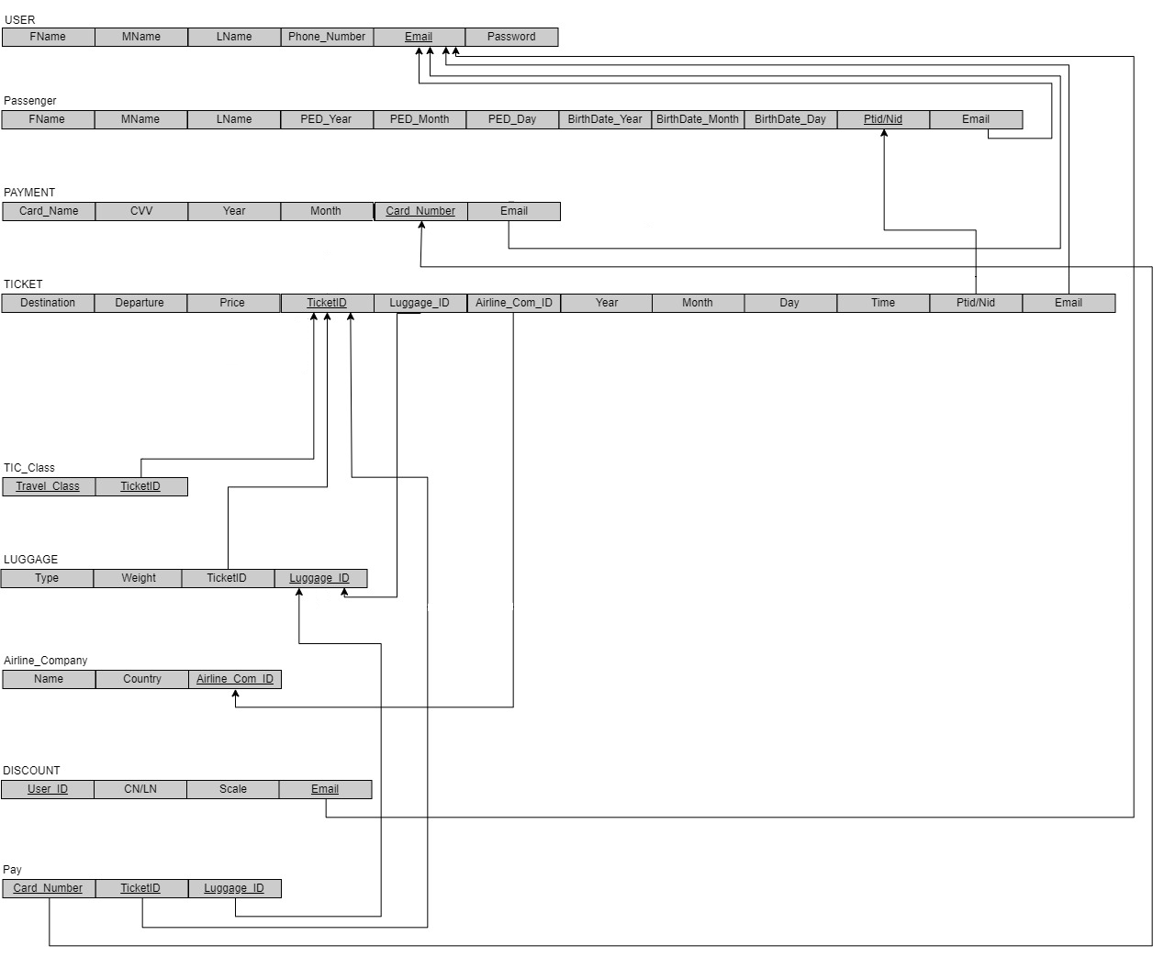**Relational schema :**

**Implementation:**

**USER:**

CREATE TABLE USER (

FName VARCHAR(10) NOT NULL,

MName VARCHAR(10) NOT NULL,

LFName VARCHAR(10) NOT NULL,

Phone_Number INT NOT NULL,

Email VARCHAR(100) NOT NULL,

Password VARCHAR(30) NOT NULL,

PRIMARY KEY (`Email`));

INSERT INTO USER (FName, MName, LFName, Phone_Number, Email,Password)

VALUES ('Adel', 'Ahmad', 'Falah', 0591147987, 'Ade2l@hotmail.com', 'QWe1235r'),

('Fawzia', 'Hassan', 'Karim', 0505168579, 'Fawzia1@hotmail.com', 'G5t_rty2'),

('Mohamed', 'Khalid', 'Nasr', 0555789632, 'MohamedD1@hotmail.com', '3Er5Y678'),

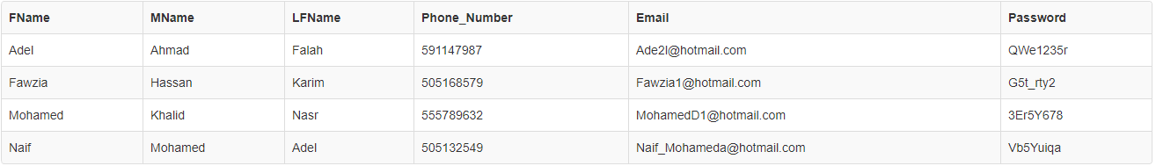('Naif', 'Mohamed', 'Adel', 0505132549, 'Naif_Mohameda@hotmail.com', 'Vb5Yuiqa');

**Passenger:**

CREATE TABLE `Passenger` (

`FName` VARCHAR(45) NULL,

`MName` VARCHAR(45) NULL,

`LFName` VARCHAR(45) NULL,

PED Date not null,

`BirthDate` date not null,

`Ptid/Nid` INT NOT NULL,

`Email` VARCHAR(100) NOT NULL,

PRIMARY KEY (`Ptid/Nid`),

FOREIGN KEY (`Email`)

REFERENCES `USER` (`Email`));

INSERT INTO `Passenger` (`FName`, `MName`, `LFName`, `PED`, `BirthDate`, `Ptid/Nid`, `Email`)

VALUES ('Zara', 'Saad', 'Khalid', "2022-3-1", "1995-2-9", 1077367684, 'Ade2l@hotmail.com'),

('Mohamed', 'Khalid', 'Nasr', "2025-7-11", "1992-5-24", 1901456534, 'MohamedD1@hotmail.com'),

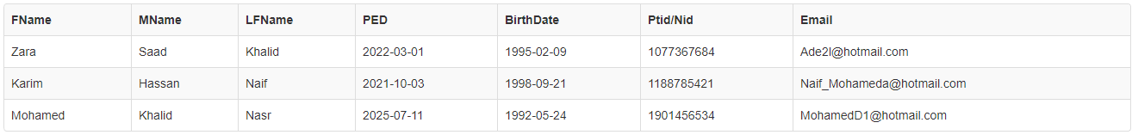('Karim', 'Hassan', 'Naif', "2021-10-3", "1998-9-21", 1188785421, 'Naif_Mohameda@hotmail.com');

**Airline Company :**

CREATE TABLE `Airline_Company` (

`Name` VARCHAR(45) NOT NULL,

`Country` VARCHAR(45) NULL,

`Airline_Com_ID` VARCHAR(10) NOT NULL,

PRIMARY KEY (`Airline_Com_ID`));

INSERT INTO `Airline_Company` (`Name`, `Country`, `Airline_Com_ID`)

VALUES ('Saudia Airlines', 'Saudi Arabia', 'A1000'),

('flydubai', 'United Arab Emirates', 'A1001'),

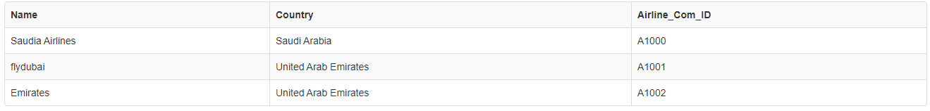 ('Emirates ', 'United Arab Emirates', 'A1002');

**TICKET:**

CREATE TABLE `TICKET` (

`Destination` VARCHAR(45) NOT NULL,

`Departure` VARCHAR(45) NOT NULL,

`Price` VARCHAR(45) NOT NULL,

`TicketID` VARCHAR(10) NOT NULL,

`Luggage_ID` VARCHAR(10) NULL,

`Airline_Com_ID` VARCHAR(10) NOT NULL,

`Year` INT(4) NOT NULL,

`Month` INT(2) NOT NULL,

`Day` INT(2) NOT NULL,

`TIME` VARCHAR(5) NOT NULL,

`Ptid/Nid` INT NOT NULL,

`Email` VARCHAR(100) NOT NULL,

PRIMARY KEY (`TicketID`),

FOREIGN KEY (`Luggage_ID`)

REFERENCES `LUGGAGE` (`Luggage_ID`),

FOREIGN KEY (`Airline_Com_ID`)

REFERENCES `Airline_Company` (`Airline_Com_ID`),

FOREIGN KEY (`Ptid/Nid`)

REFERENCES `Passenger` (`Ptid/Nid`),

FOREIGN KEY (`Email`)

REFERENCES `USER` (`Email`));

INSERT INTO `TICKET` (`Destination`, `Departure`, `Price`, `TicketID`, `Luggage_ID`, `Airline_Com_ID`, `Year`, `Month`, `Day`, `TIME`, `Ptid/Nid`, `Email`)

VALUES ('Hail','Riyadh','250','T1000','L1000','A1000', 2019, 11, 16, '14:00', 1077367684,'Ade2l@hotmail.com'),

 ('Jeddah','Tabuk','350','T1001','L1001','A1000', 2019, 11, 17, '16:00', 1901456534,'MohamedD1@hotmail.com');

**LUGGAGE:**

CREATE TABLE `LUGGAGE` (

`Type` VARCHAR(45) NULL,

`Weight` INT(2) NULL,

`TicketID` VARCHAR(45) NOT NULL,

`Luggage_ID` VARCHAR(10) NOT NULL,

PRIMARY KEY (`Luggage_ID`),

FOREIGN KEY (`TicketID`)

REFERENCES `mydb`.`TICKET` (`TicketID`));

INSERT INTO `LUGGAGE` (`Type`, `Weight`, `TicketID`, `Luggage_ID`)

VALUES ('box', 25, 'T1000', 'L1000'),

 ('Wheeled Duffels', 15, 'T1001', 'L1001');

**PAYMENT:**

**CREATE TABLE `PAYMENT` (**

**`Card_Name` VARCHAR(45) NOT NULL,**

**`CVV` INT(3) NOT NULL,**

**`Year` INT(2) NOT NULL,**

**`month` INT(2) NOT NULL,**

**`Card_Number` INT(45) NOT NULL,**

**`Email` VARCHAR(100) NOT NULL,**

**PRIMARY KEY (`Card_Number`),**

**FOREIGN KEY (`Email`)**

**REFERENCES `USER` (`Email`));**

**INSERT INTO `PAYMENT` (`Card_Name`, `CVV`, `Year`, `month `, `Card_Number`, `Email`)**

**VALUES ('Adel Falah', 885, 20, 03,561059108,'Ade2l@hotmail.com');**

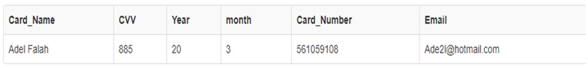

**TICKET CLASS:**

CREATE TABLE `TIC_Class` (

`Travel_Class` VARCHAR(15) NOT NULL,

`TicketID` VARCHAR(10) NOT NULL,

PRIMARY KEY (`Travel_Class`, `TicketID`));

INSERT INTO `TIC_Class` (`Travel_Class`, `TicketID`)

VALUES ('Business class', 'T1000'),

('Economy class', 'T1001');

**DISCOUNT:**

CREATE table `DISCOUNT` (

`User_ID` VARCHAR(10) NOT NULL,

`CN/LN` VARCHAR(45) NOT NULL,

`Scale` INT(2) NULL,

`Email` VARCHAR(100) NOT NULL,

PRIMARY KEY (`User_ID`,`Email`));

INSERT INTO `DISCOUNT` (`User_ID`, `CN/LN`, `Scale`, `Email`)

 VALUES ('1099987858', 'Falah', 25, 'Ade2l@hotmail.com')

**PAY :**

CREATE TABLE `Pay` (

`Card_Number` INT(45) NOT NULL,

`TicketID` VARCHAR(10) NOT NULL,

`Luggage_ID` VARCHAR(10) NULL,

PRIMARY KEY (`Card_Number`, `TicketID`, `Luggage_ID`));

INSERT INTO `Pay` (`Card_Number`, `TicketID`, `Luggage_ID`)

 VALUES (561059108, 'T1000', 'L1000');

6-Conclusion

The database design has been completed in the following stages:

* Requirements collection.
* Draw ER model diagram.
* Draw schema and relationship.
* Implementation